**WWF – Risk Management System (RMS)**

**Functional Requirements & Design (FRD) Document**

(Version 0)

***Document Overview***

|  |  |  |  |
| --- | --- | --- | --- |
| Title | FRD_Risk Mngt_V0.docx | Version | V0 |
| Project | WWF – Risk Management System | Status | Draft |
| Client | Mr. Samuel | Type | Internal / External |
| Author | Mr. Rajendra | Last Save | 23-07-2018 |
| Reviewed By | Mr. Keerthi Venkatesh | | |  |
| Comments: | | | |
|  | | | |

***Revision History***

|  |  |  |  |  |
| --- | --- | --- | --- | --- |
| **Ver. #** | **Rev Date** | **Author** | **Dist. Date** | **Brief Description** |
|  |  |  |  |  |
|  |  |  |  |  |
|  |  |  |  |  |

***Distribution List***

1. ***Baryons Stakeholders***
2. ***Delivery Team***

***Approved By***

|  |  |  |
| --- | --- | --- |
| **Name** | **Role** | **Version** |
|  |  |  |
|  |  |  |
|  |  |  |
|  |  |  |

Contents

1. Context: 5

2. Admin Login and Logout 6

3. User Roles 6

4. Masters 6

4.1 Risk Effect 6

4.2 Risk Source 7

4.3 Risk Evaluation 7

4.4 Risk Movement 8

4.5 Insight User 8

4.6 Insight Office 8

4.7 Risk Likelihood Rating 8

4.8 Risk Impact Rating 9

4.9 Risk Control 9

4.10 Key Risk Indicator 10

5. Risk Register 10

6. Reports 13

7. SSO Integration 13

8. Database Design 13

Table of Contents of User Stories

|  |  |
| --- | --- |
| **SL No** | **User Stories** |
| 1 | Admin Login and Logout |
| 2 | User Roles |
| 3 | Masters   * Risk Effect * Risk Source * Risk Evaluation * Risk Movement * Insight User * Insight Office * Risk Likelihood Rating * Risk Impact Rating * Risk Control * Key Risk Indicator |
| 4 | Risk Register |
| 5 | Reports |
| 6 | SSO Integration |

# Context:

Obtain a suitable solution to support WWF risk management process

Baryons must create the frontend application which will use MSSQL as backend. Baryons will develop the frontend using PHP MVC Framework (CodeIgniter)and other web technologies like HTML 5, CSS (Bootstrap framework), jQuery.

# Admin Login and Logout

As an Administrator need to browse the RMS application URL and login successfully so that I can access the application and logout successfully.

# User Roles

1. The system will have three roles named

* **WWF International Manager** – Access to all offices
* **Risk Manager or Super Admin** – Per Office
* **Risk Owner** - can input and edit risks for one office - but not admin

1. The system users will be fetched from the “INSIGHT_USER” table. Once the user is logged into the system through SSO will show all the Office information owned by the user.

# Masters

# Risk Effect

As an administrator, need to create Risk Effect in the Risk Effect Master so that the created list of values should able to list and selected while add Risk Register.

**HOME -> Master->Risk Effect**

1. RISK_EFFECT_ID
2. RISK_EFFECT_CATEGORY
3. CREATED_BY
4. CREATED_DATE
5. UPDATED_BY
6. UPDATED_DATE

Risk Effect Category is selected while creating a Risk Register.

Predefined Values are:

S - Strategic

F - Finance

P - People

R - Reputation

O - Operation/Quality

# Risk Source

As an administrator, need to create Risk Source in the Risk Source Master so that the created list of values should able to list and selected while add Risk Register.

**HOME -> Master->Risk Source**

1. RISK_SOURCE_ID
2. RISK_SOURCE_CATEGORY
3. CREATED_BY
4. CREATED_DATE
5. UPDATED_BY
6. UPDATED_DATE

Risk Source Category is selected while creating a Risk Register.

Predefined Values are:

E-External

S- Strategic

C- Compliance &Fraud

O- Operational

P- People

F- Financial

T- Technology

# Risk Evaluation

As an administrator, need to create Risk Evaluation in the Risk Evaluation Master so that the created list of values should able to list and selected while add Risk Register.

**HOME -> Master->Risk Evaluation**

1. RISK_EVALUATION_ID
2. RISK_EVALUATION_STATUS
3. CREATED_BY
4. CREATED_DATE
5. UPDATED_BY
6. UPDATED_DATE

Risk Evaluation is selected while creating a Risk Register.

Predefined Values are:

High

Medium

Low

Condition: High > 18, Medium 6-17, Low < 6

# Risk Movement

As an administrator, need to create Risk Movement in the Risk Movement Master so that the created list of values should able to list and selected while add Risk Register.

**HOME -> Master->Risk Movement**

1. RISK_MOVEMENT_ID
2. RISK_MOVEMENT_STATUS
3. CREATED_BY
4. CREATED_DATE
5. UPDATED_BY
6. UPDATED_DATE

Risk Movement is selected while creating a Risk Register.

Predefined Values are:

Increased

Unchanged

Decreased

# Risk Owner

As an administrator, need to select the Risk Owner which is mapped for all the WWF application and should able to select while Add Risk Register

# Office Name

As an administrator, need to select the Office name which is mapped for all the WWF application and should able to select while Add Risk Register

# Risk Likelihood Rating

As an administrator, need to create Risk Likelihood Rating in the Risk Likelihood Rating Master so that the created list of values should able to list and selected while add Risk Register.

**HOME -> Master->Risk Likelihood Rating**

1. LIKELIHOOD_RATING_ID
2. DESCRIPTOR
3. PROBABLITY
4. FREQUENCY
5. CREATED_BY
6. CREATED_DATE
7. UPDATED_BY
8. UPDATED_DATE

Rating - Descriptor is selected while creating a Risk Register.

Predefined Values are:

1 - Remote

2 - Unlikely

3 - Moderate

4 - Likely

5 - Very likely

# Risk Impact Rating

As an administrator, need to create Risk Impact Rating in the Risk Impact Rating Master so that the created list of values should able to list and selected while add Risk Register.

**HOME -> Master->Risk Impact Rating**

1. IMPACT_RATING_ID
2. DESCRIPTOR
3. STRATEGIC_OBJECTIVES_IMPACT
4. FINANCIAL
5. OPERATIONAL
6. PEOPLE
7. REPUTATION
8. CREATED_BY
9. CREATED_DATE
10. UPDATED_BY
11. UPDATED_DATE

Rating - Descriptor is selected while creating a Risk Register.

Predefined Values are:

1 - Negligible

2 - Minor

3 - Moderate

4 - Moderate

5 – Critical

# Risk Control

As an administrator, need to create Risk Control in the Risk Control Master so that the created list of values should able to list and selected while add Risk Register.

**HOME -> Master->Risk Control**

1. RISK_CONTROL_ID
2. CONTROL_TYPE
3. CREATED_BY
4. CREATED_DATE
5. UPDATED_BY
6. UPDATED_DATE

Control Type is selected while creating a Risk Register.

# Key Risk Indicator

As an administrator, need to create Key Risk Indicator in the Key Risk Indicator Master so that the created list of values should able to list and selected while add Risk Register.

**HOME -> Master-> Key Risk Indicator**

1. RISK_KEY_INDICATOR_ID
2. RISK_KEY_INDICATOR_DESC
3. CREATED_BY
4. CREATED_DATE
5. UPDATED_BY
6. UPDATED_DATE

Key Indicator Description is selected while creating a Risk Register.

Predefined Values are:

Number of Incidents per month

# Risk Register

As an administrator, need to create/list/edit/search the Risk Register.

Risk Register can be searched with these fields

1. Risk Name
2. Risk Effect
3. Risk Source
4. Risk Evaluation
5. Responsibility
6. Insight User
7. Implementation Date

**Fields for creating Risk Register**

RISK NAME

RISK IDENTIFIED

OBJECTIVE

PROCESS

SUBPROCESS

GROSS RISK

NET RISK

PREVENTIVE CONTROLS

DETECTIVE CONTROLS

KEY RISK INDICATOR

MOVEMENT LAST SIX MONTHS DESC

RISK TREATMENT ACTION PLAN

RISK EFFECT

RISK SOURCE

GROSS LIKELIHOOD

GROSS IMPACT

RISK EVALUATION

NET LIKELIHOOD

NET IMPACT

MOVEMENT LAST SIX MONTHS

USER NAME

OFFICE NAME

IMPLEMENTATION DATE

Risk Register Form with Mandatory Fields:

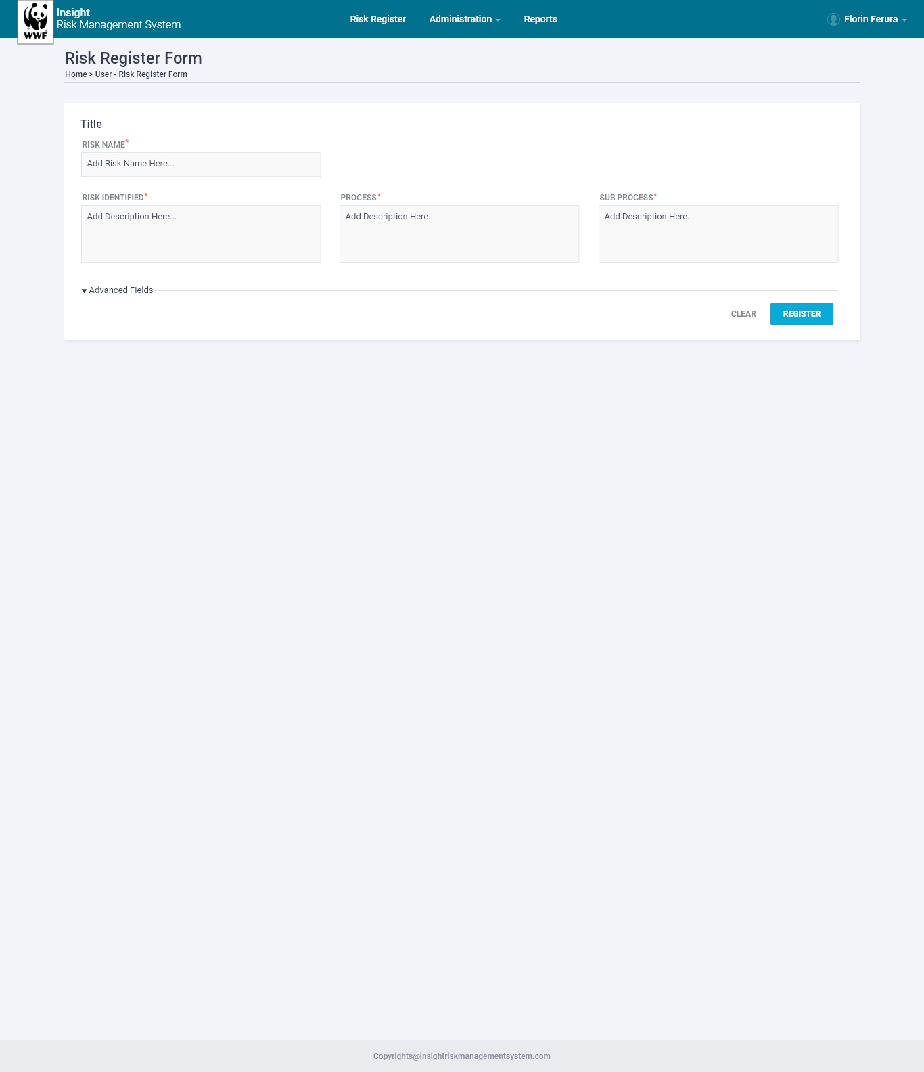

Risk Register Form with Advanced Fields:

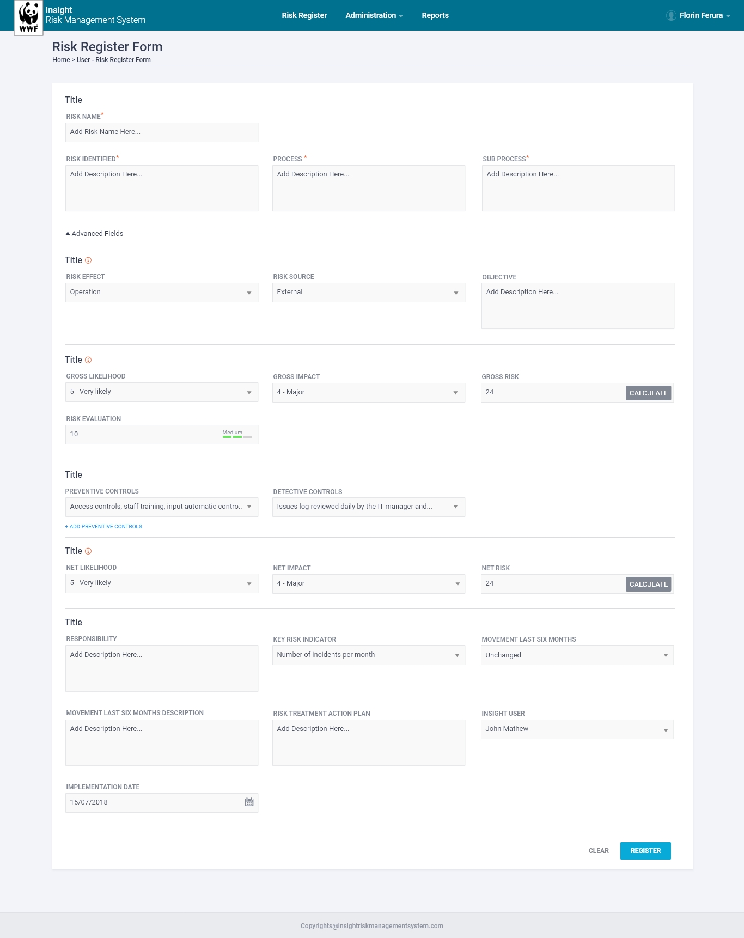

# Reports

As an administrator, need to generate logical Reports so that I can get the status and list of RMS reports etc.

# SSO Integration

SSO need to be implemented on the site so that the users from different WWF sites like Insight, GRR, GTFN, Audit can also use the same credentials to login here based on the Roles and permissions set by administrator.

# Database Design

|  |  |  |  |  |
| --- | --- | --- | --- | --- |
| **RMS_RISK_REGISTER** | | | | |
| **Fields** | **Type** | **Key** | **Comment** | **Default Value** |
| RISK_ID | INT | PK,AI |  |  |
| RISK_NAME | VARCHAR(150) |  |  |  |
| RISK_IDENTIFIED | TEXT |  |  |  |
| OBJECTIVE | TEXT |  |  |  |
| PROCESS | TEXT |  |  |  |
| SUBPROCESS | TEXT |  |  |  |
| GROSS_RISK | VARCHAR(150) |  |  |  |
| NET_RISK | VARCHAR(150) |  |  |  |
| PREVENTIVE_CONTROLS | TEXT |  |  |  |
| DETECTIVE_CONTROLS | TEXT |  |  |  |
| KEY_RISK_INDICATOR | TEXT |  |  |  |
| MOVEMENT_LAST_SIX_MONTHS_DESC | TEXT |  |  |  |
| RISK_TREATMENT_ACTION_PLAN | TEXT |  |  |  |
| RISK_EFFECT_ID | INT | FK['RMS_RISK_EFFECT'] |  |  |
| RISK_SOURCE_ID | INT | FK['RMS_RISK_SOURCE'] |  |  |
| GROSS_LIKELIHOOD_ID | INT | FK['RMS_RISK_LIKEKIHOOD_RATING'] |  |  |
| GROSS_IMPACT_ID | INT | FK['RMS_RISK_IMPACT_RATING'] |  |  |
| RISK_EVALUATION_ID | INT | FK['RMS_RISK_EVALUTION'] |  |  |
| NET_LIKELIHOOD_ID | INT | FK['RMS_RISK_LIKEKIHOOD_RATING'] |  |  |
| NET_IMPACT_ID | INT | FK['RMS_RISK_IMPACT_RATING'] |  |  |
| MOVEMENT_LAST_SIX_MONTHS_ID | INT |  | Increased, Unchanged, Decreased |  |
| USER_ID | INT | FK['INSIGHT_USER'][USER_ID] |  |  |
| OFFICE_ID | INT | FK['INSIGHT_OFFICE'][OFFICE_ID] |  |  |
| IMPLEMENTATION | DATE |  |  |  |
| CREATED_BY | INT |  |  |  |
| CREATED_DATE | DATETIME |  |  |  |
| UPDATED_BY | INT |  |  |  |
| UPDATED_DATE | DATETIME |  |  |  |
|  |  |  |  |  |
|  |  |  |  |  |
| **MASTERS TABLES** | | | | |
|  |  |  |  |  |
| **RMS_RISK_EFFECT** | | | | |
| **Fields** | **Type** | **Key** | **Comment** | **Default Value** |
| RISK_EFFECT_ID | INT | PK,AI |  |  |
| RISK_EFFECT_CATEGORY | VARCHAR(150) |  | S - Strategic F - Finance P - People R - Reputation O - Operation/Quality |  |
| CREATED_BY | INT |  |  |  |
| CREATED_DATE | DATETIME |  |  |  |
| UPDATED_BY | INT |  |  |  |
| UPDATED_DATE | DATETIME |  |  |  |
|  |  |  |  |  |
| **RMS_RISK_SOURCE** | | | | |
| **Fields** | **Type** | **Key** | **Comment** | **Default Value** |
| RISK_SOURCE_ID | INT | PK,AI |  |  |
| RISK_SOURCE_CATEGORY | VARCHAR(150) |  | E-External S- Strategic C- Compliance &Fraud O- Operational P- People F- Financial T- Technology |  |
| CREATED_BY | INT |  |  |  |
| CREATED_DATE | DATETIME |  |  |  |
| UPDATED_BY | INT |  |  |  |
| UPDATED_DATE | DATETIME |  |  |  |
|  |  |  |  |  |
| **RMS_RISK_EVALUATION** | | | | |
| **Fields** | **Type** | **Key** | **Comment** | **Default Value** |
| RISK_EVALUATION_ID | INT | PK,AI |  |  |
| RISK_EVALUATION_STATUS | VARCHAR |  | HIGH,MEDIUM,LOW (High > 18, Medium 6-17 ,Low < 6) |  |
| CREATED_BY | INT |  |  |  |
| CREATED_DATE | DATETIME |  |  |  |
| UPDATED_BY | INT |  |  |  |
| UPDATED_DATE | DATETIME |  |  |  |
|  |  |  |  |  |
| **RMS_RISK_MOVEMENT** | | | | |
| **Fields** | **Type** | **Key** | **Comment** | **Default Value** |
| RISK_MOVEMENT_ID | INT | PK,AI |  |  |
| RISK_MOVEMENT_STATUS | VARCHAR(150) |  | Increased, Unchanged, Decreased |  |
| CREATED_BY | INT |  |  |  |
| CREATED_DATE | DATETIME |  |  |  |
| UPDATED_BY | INT |  |  |  |
| UPDATED_DATE | DATETIME |  |  |  |
|  |  |  |  |  |
| **INSIGHT_USER** | | | | |
| **Fields** | **Type** | **Key** | **Comment** | **Default Value** |
| USER_ID | INT | PK,AI |  |  |
| USER_NAME | VARCHAR(150) |  |  |  |
|  |  |  |  |  |
| **INSIGHT_OFFICE** | | | | |
|  |  |  |  |  |
| **Fields** | **Type** | **Key** | **Comment** | **Default Value** |
| OFFICE_ID | INT | PK,AI |  |  |
| OFFICE_NAME | VARCHAR(150) |  |  |  |
|  |  |  |  |  |
| **RMS_RISK_LIKELIHOOD_RATING** | | | | |
| **Fields** | **Type** | **Key** | **Comment** | **Default Value** |
| LIKELIHOOD_RATING_ID | INT | PK,AI |  |  |
| DESCRIPTOR | VARCHAR(150) |  | Remote,Unlikely,Moderate,Likely,Very likely |  |
| PROBABLITY | VARCHAR(150) |  | <5%,<25%,25-50%,50-75%,>75% |  |
| FREQUENCY | VARCHAR(150) |  | May occur in the next 5 years May occur in the next 3 years May occur in the next 2 years May occur in the next 1 year. May occur in the next 6 months |  |
| CREATED_BY | INT |  |  |  |
| CREATED_DATE | DATETIME |  |  |  |
| UPDATED_BY | INT |  |  |  |
| UPDATED_DATE | DATETIME |  |  |  |
|  |  |  |  |  |
| **RMS_RISK_IMPACT_RATING** | | | | |
| **Fields** | **Type** | **Key** | **Comment** | **Default Value** |
| IMPACT_RATING_ID | INT | PK,AI |  |  |
| DESCRIPTOR | VARCHAR(150) |  | Negligible Minor Moderate Major Critical |  |
| STRATEGIC_OBJECTIVES_IMPACT | VARCHAR(150) |  | Negligible or no impact on strategic objectives Minor impact on strategic objectives Moderate disruption to activities One or more strategic objectives are adversely impacted A strategic objective cannot be achieved More than one strategic objective cannot be achieved |  |
| FINANCIAL | VARCHAR(150) |  | < 100K 100K to < 500K 500K to < 1million 1 million to < 5 million > 5 million |  |
| OPERATIONAL | VARCHAR(150) |  | Minimal effect on operations Negligible quality issues Potential for up to 1 month delay in operations Quality diminished slightly Potential for up to 3 months delay in operations Quality diminished substantially Potential for up to 6 months delay in operations Substantial impact on the quality of delivery  Potential for 12+ months delay in operations Quality issues lead to non-achievement of objectives |  |
| PEOPLE | VARCHAR(150) |  | No apparent injury Displeasure of staff voiced internally only Minor injury/first aid on site Displeasure of staff voiced externally Reportable injury, including partial invalidity, but no loss of life Moderate decrease in staff moral Loss of life or serious injury High outflow of employees from the office or program Multiple loss of life or serious injury Moral discretion of WWF |  |
| REPUTATION | VARCHAR(150) |  | Negligible or no damage to reputation Negligible adverse local media attention Minor damage to reputation  Minor adverse local media attention or complaints Moderate damage to reputation and / or credibility Moderate adverse national media coverage Major damage to reputation and / or credibility  Significant adverse media coverage extending over a number of days and countries Significant damage to reputation and / or and loss of confidence of donors International condemnation |  |
| CREATED_BY | INT |  |  |  |
| CREATED_DATE | DATETIME |  |  |  |
| UPDATED_BY | INT |  |  |  |
| UPDATED_DATE | DATETIME |  |  |  |
|  |  |  |  |  |
| **RMS_RISK_CONTROL** | | | | |
| **Fields** | **Type** | **Key** | **Comment** | **Default Value** |
| RISK_CONTROL_ID | INT | PK,AI |  |  |
| CONTROL_TYPE | VARCHAR |  | Preventive Control, Detective Control |  |
| CREATED_BY | INT |  |  |  |
| CREATED_DATE | DATETIME |  |  |  |
| UPDATED_BY | INT |  |  |  |
| UPDATED_DATE | DATETIME |  |  |  |
|  |  |  |  |  |
| **RMS_KEY_RISK_INDICATOR** | | | | |
| **Fields** | **Type** | **Key** | **Comment** | **Default Value** |
| RISK_KEY_INDICATOR_ID | INT | PK,AI |  |  |
| RISK_KEY_INDICATOR_DESC | TEXT |  |  |  |
| CREATED_BY | INT |  |  |  |
| CREATED_DATE | DATETIME |  |  |  |
| UPDATED_BY | INT |  |  |  |
| UPDATED_DATE | DATETIME |  |  |  |
|  |  |  |  |  |
| **MAPPING TABLES** | | | | |
|  |  |  |  |  |
| **RMS_REGISTER_CONTROL** | | | | |
| **Fields** | **Type** | **Key** | **Comment** | **Default Value** |
| REGISTER_CONTROL_ID | INT | PK,AI |  |  |
| RISK_ID | INT | FK['RMS_RISK_RIGESTER'] |  |  |
| RISK_CONTROL_ID | INT | FK['RMS_RISK_CONTROL'] |  |  |
| CREATED_BY | INT |  |  |  |
| CREATED_DATE | DATETIME |  |  |  |
| UPDATED_BY | INT |  |  |  |
| UPDATED_DATE | DATETIME |  |  |  |
|  |  |  |  |  |
| **RMS_REGISTER_INDICATOR** | | | | |
| **Fields** | **Type** | **Key** | **Comment** | **Default Value** |
| REGISTER_INDICATOR_ID | INT | PK,AI |  |  |
| RISK_ID | INT | FK['RMS_RISK_RIGESTER'] |  |  |
| RISK_KEY_INDICATOR_ID | INT | FK['RMS_KEY_RISK_INDICATOR'] |  |  |
| CREATED_BY | INT |  |  |  |
| CREATED_DATE | DATETIME |  |  |  |
| UPDATED_BY | INT |  |  |  |
| UPDATED_DATE | DATETIME |  |  |  |